**Project 1: Implementing 2PL protocol**

**Intermediate Report**

**Team Details:**

Ridham Kothari (1001446086)

Yash Shah (1001563334)

**Pseudo-code for the program**:

**Function main:**

# Database connection to MYSQL

db = mysql_connection()

# For part -1 of the project

retrieve the result for Team_Scores from mysql using following query

**SELECT** g.matchDate,

S.Scity, S.SName,

t.team **AS** team1,

g.team1Score,

v.team **AS** team2,

g.team2Score

**FROM** team **AS** t,

stadium **AS** s,

game **AS** g,

team **AS** v

**WHERE** t.teamID = g.TeamID1 **AND**

g.SID = s.SID **AND**

v.teamID = g.teamID2;

convert the result to JSON

insert data into mongoDb

#For part-2 of the project

retrieve the result for Player_data from mysql using following query

**SELECT** p.pname, p.team,

p.pno, p.position,

g.matchDate, s.scity,

s.sname, v.team,

go.penalty, go.gtime,

g.matchdate, s.scity,

s.sname, v.team

**FROM** player **AS** p,

team **AS** t,

team **AS** v,

stadium **AS** s,

game **AS** g,

goal **as** go

**WHERE** p.teamid = t.teamID **AND**

g.sid = s.sid **AND**

g.teamid2 = v.teamid **AND**

g.teamid1 = p.teamid **AND**

go.gameid = g.gameid **AND**

go.pno = p.pno **AND**

go.teamid = p.teamid;

convert the result to JSON

insert data into mongoDb

# connect to MYSQL database

**Def mysql_connection():**

Set the parameters to connect to MYSQL DB

Return connection object

# connect to mongo database

**Def mongoDb_connection():**

Set the parameters to connect to mongoDB

Return connection object

**Data Structure:**

We have used MYSQL to store the give data. Screenshot of loaded data is as follows:

**TEAM**:

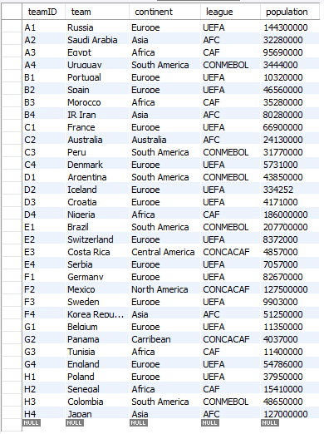

**PLAYER**:

A screenshot of a cell phone

Description generated with high confidence

**STADIUM**:

A screenshot of a cell phone

Description generated with very high confidence

**GAME**:

A screenshot of a cell phone

Description generated with high confidence

**GOAL**:

A screenshot of a cell phone

Description generated with high confidence

**STARTINGLINEUP**:

A screenshot of a cell phone

Description generated with high confidence

**Sample data from MongoDB:**

A screenshot of a cell phone

Description generated with high confidence